PO-PROCUREMENT OF MATERIALS AGAINST PROJECT

Home and 1 more page - Personal - Microsoft​ Edge
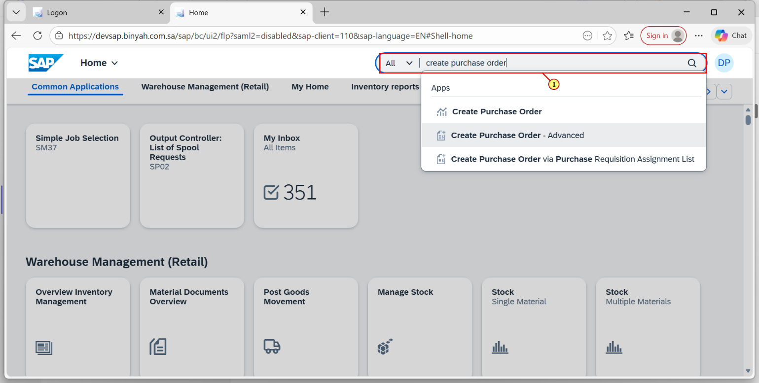
Step | Action
(1) | Search and Open "Create Purchase Order-Advanced".

Create Purchase Order and 1 more page - Personal - Microsoft​ Edge
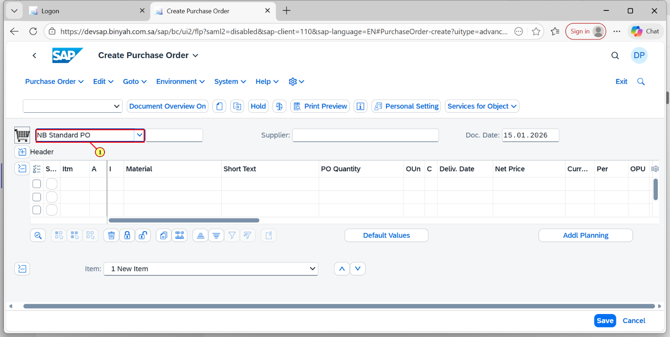
Step | Action
(1) | Select the Document type according to the process.

Create Purchase Order and 1 more page - Personal - Microsoft​ Edge
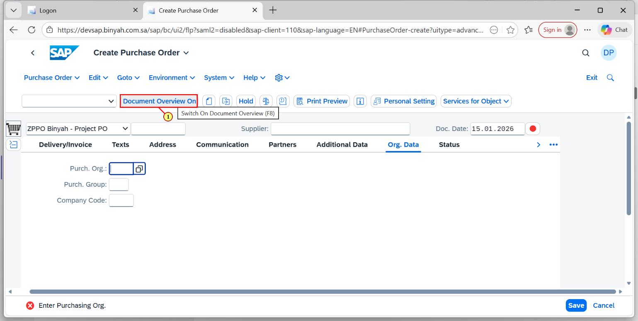
Step | Action
(1) | Click "Document Overview" ON.

Create Purchase Order and 1 more page - Personal - Microsoft​ Edge
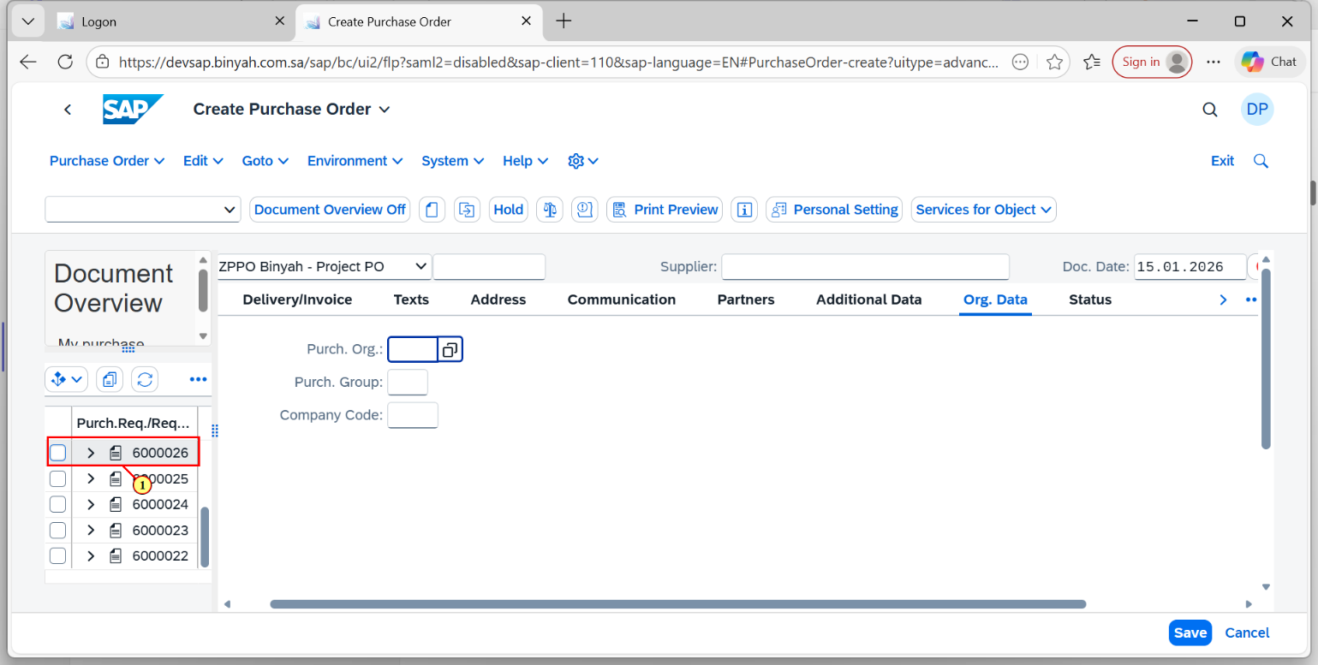
Step | Action
(1) | Select "Purchase Requisition" selection variant. Enter the PR that you want to convert as PO.

Create Purchase Order and 1 more page - Personal - Microsoft​ Edge
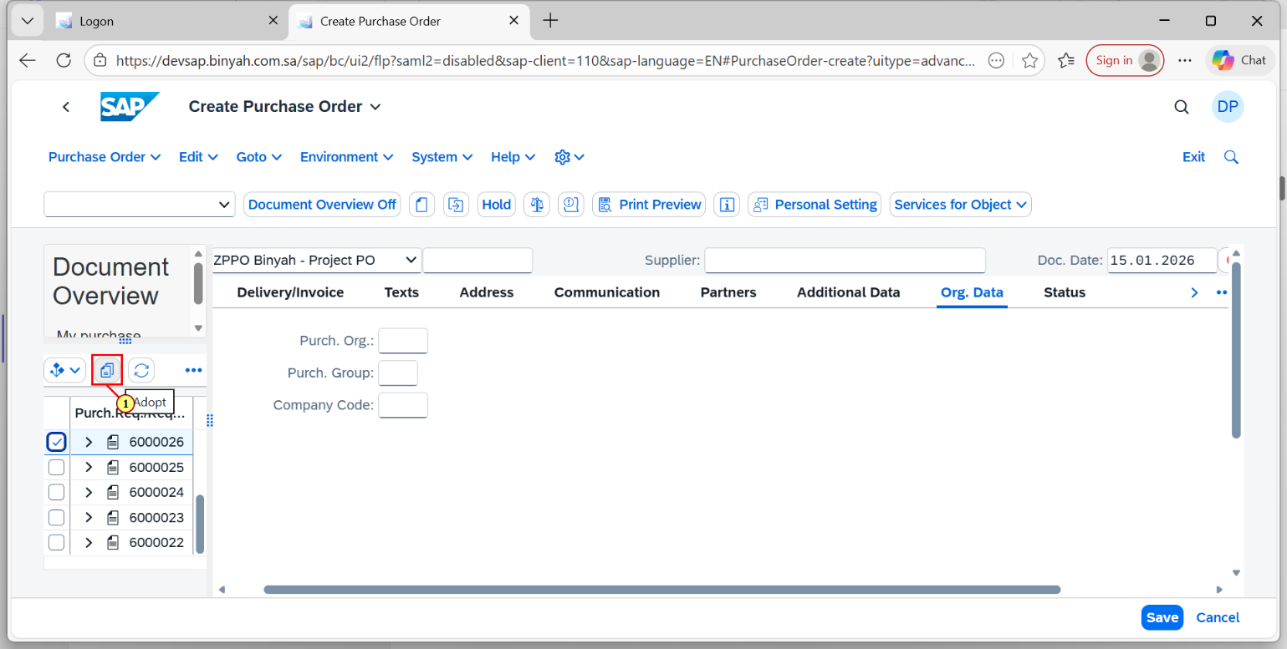
Step | Action
(1) | Click "Adopt".

Create Purchase Order and 1 more page - Personal - Microsoft​ Edge
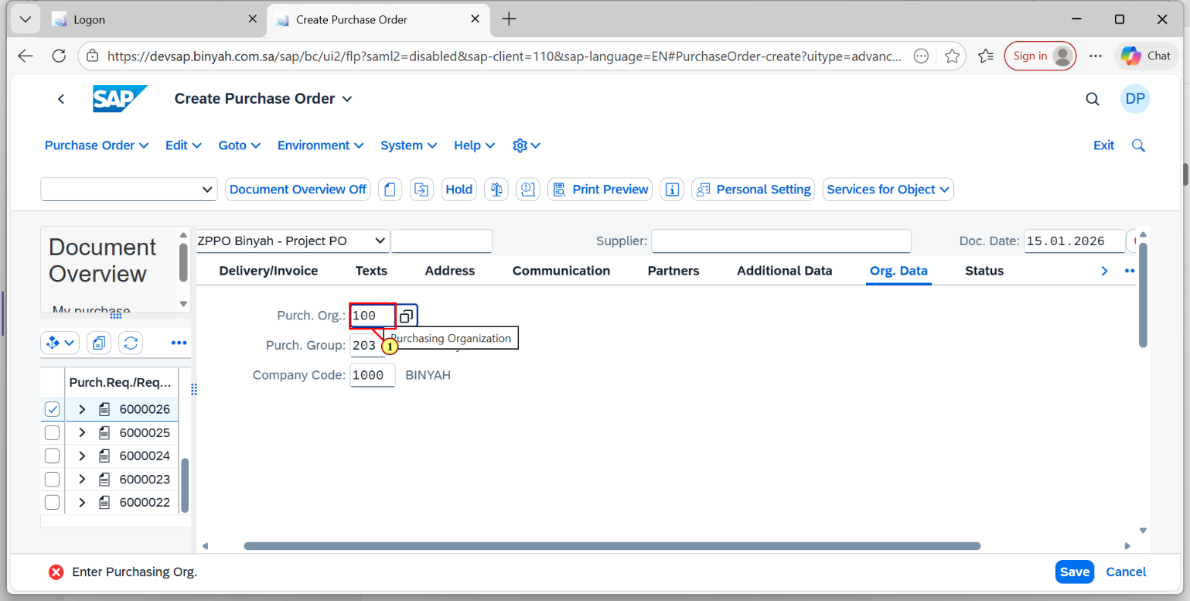
Step | Action
(1) | Enter the "Purchase Organization".

Create Purchase Order and 1 more page - Personal - Microsoft​ Edge
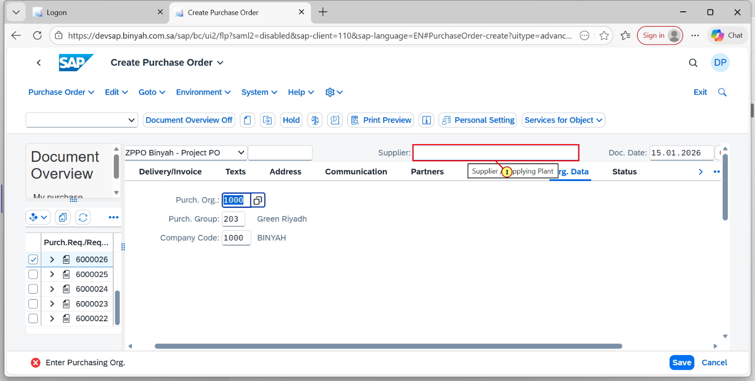
Step | Action
(1) | Enter the "Supplier".

Create Purchase Order and 1 more page - Personal - Microsoft​ Edge
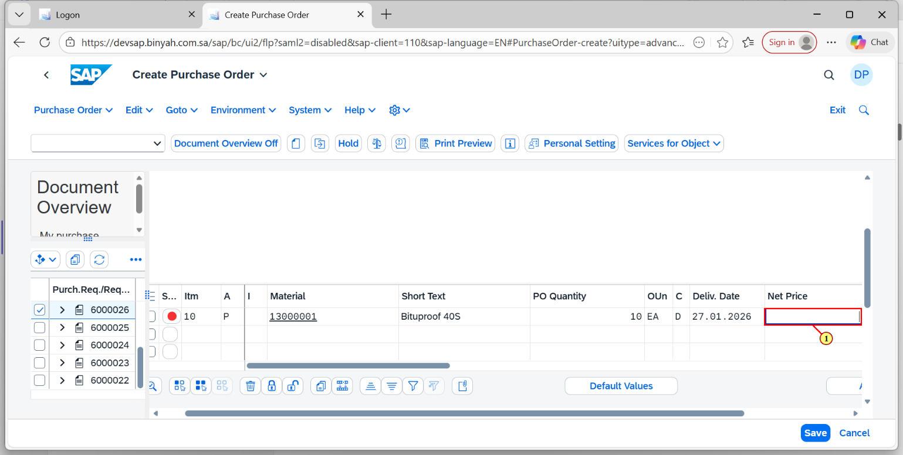
Step | Action
(1) | Enter the Net Price.

Create Purchase Order and 1 more page - Personal - Microsoft​ Edge
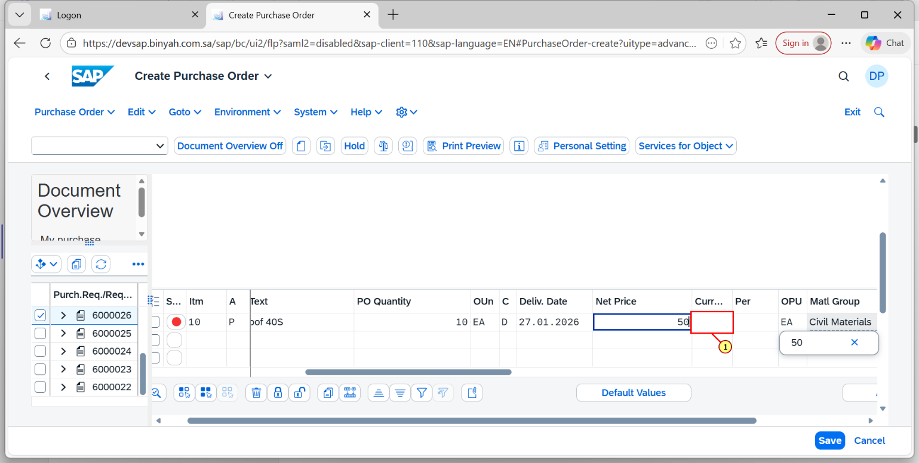
Step | Action
(1) | Enter the Currency.

Create Purchase Order and 1 more page - Personal - Microsoft​ Edge
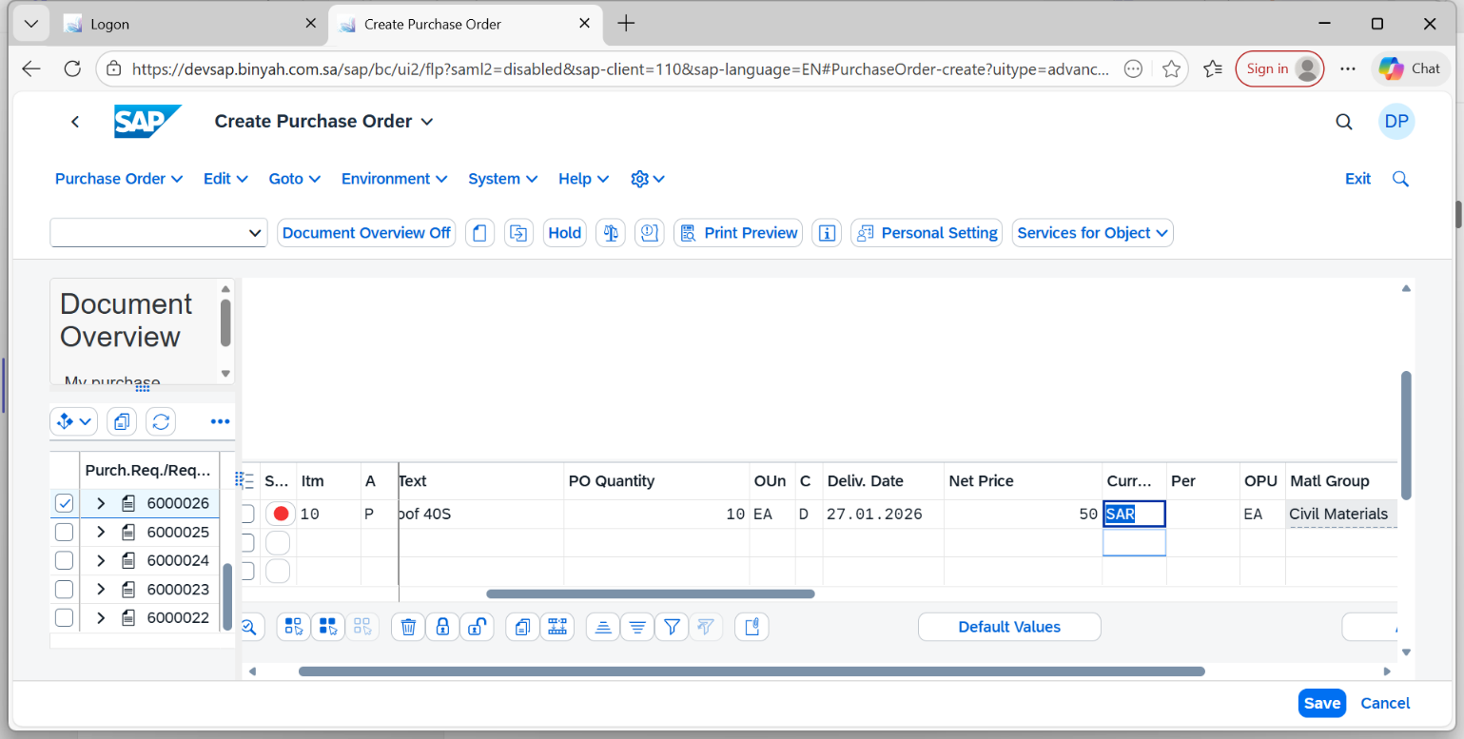
Step | Action
 | Press "Enter".

Create Purchase Order and 1 more page - Personal - Microsoft​ Edge
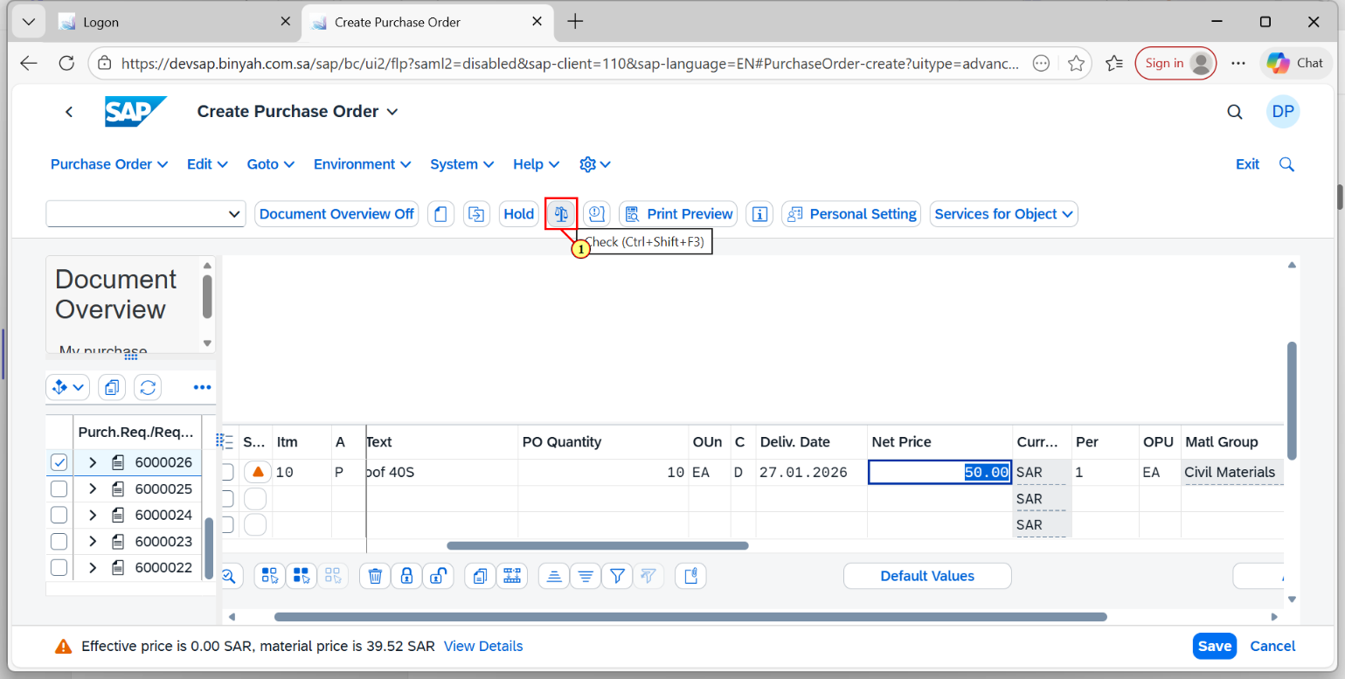
Step | Action
(1) | Click "Check".

Create Purchase Order and 1 more page - Personal - Microsoft​ Edge
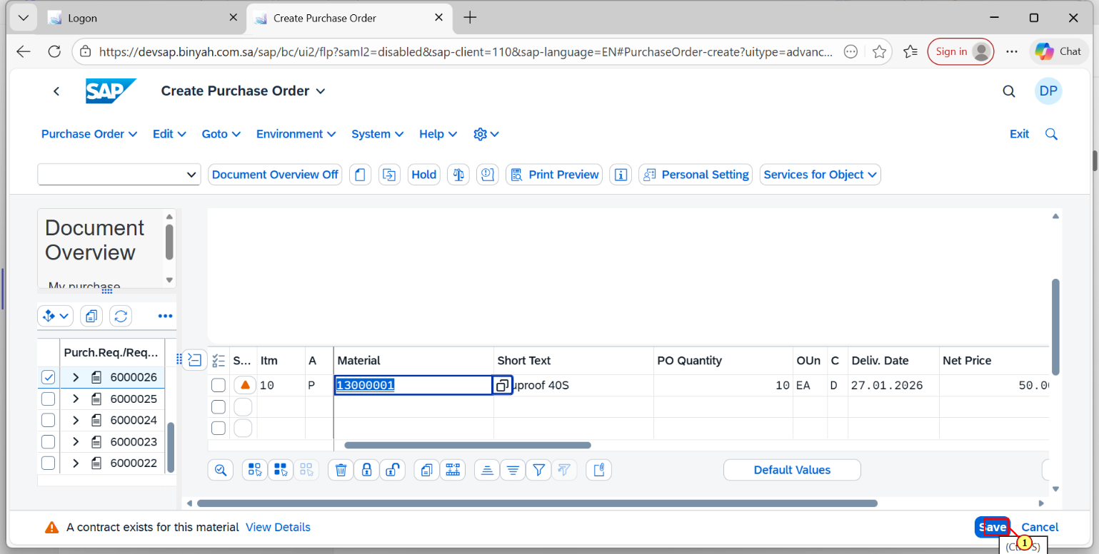
Step | Action
(1) | Click on "Save".

Create Purchase Order and 1 more page - Personal - Microsoft​ Edge
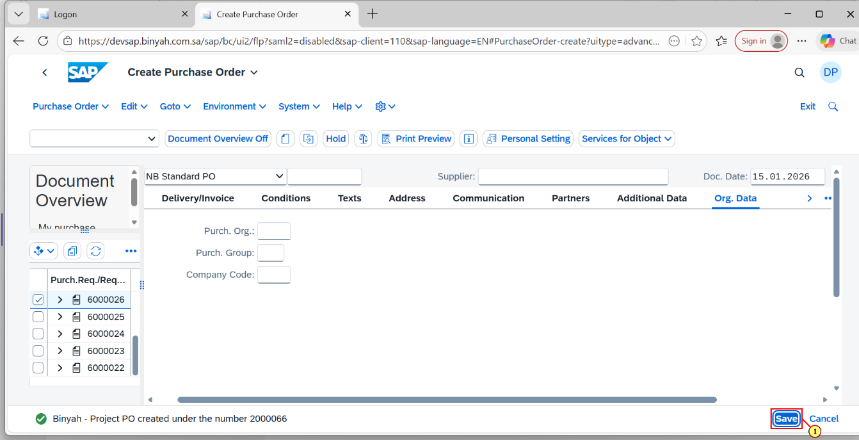
(1) | After clicking "Save", PO is Created.

